Name _____________________________________________

Unit 3 Review – Matter
Section 3-1 Notes
- Matter has volume and mass
- Physical properties include: color, shape, texture, density, phase of matter, malleability and solubility
- Chemical properties include: flammability, reactivity
- Physical changes – when you change a physical property
- Chemical changes – when something new is created (composition of substance is changed)
  - Signs of chemical changes include: gas formation, light formation, heat formation, color/odor change
- Kinetic Molecular Theory – all matter is made of particles that are constantly in motion
- Solids – definite shape/definite volume, tightly packed particles, particles move slowly
- Liquids – no definite shape/definite volume, particles close and slide past one another, move at a medium speed
- Gas – no definite shape/no definite volume, particles very spread out, move quickly
Section 3-2 Notes
- ALL PHASE CHANGES ARE PHYSICAL CHANGES
- Melting, vaporization and sublimation (left to right) are all phase changes that include:
  - Added heat (thermal) energy
  - Increase in temperature
  - Increase in particle speed (motion)
  - Increased space between particles
- Freezing, condensation and deposition (right to left) are all phase changes that include:
  - Removal of heat (thermal) energy
  - Decrease in temperature
  - Decrease in particle speed (motion)
  - Decreased space between particles
- Melting – solid to liquid
- Freezing – liquid to solid
- Vaporization (included evaporation and boiling) - liquid to gas
- Condensation – gas to liquid
- Sublimation – Solid directly to a gas
- Deposition – Gas directly to a solid
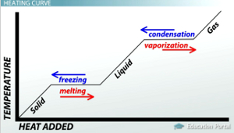
- MELTING/FREEZING POINT OF WATER = 0⁰ C
- BOILING POINT OF WATER = 100⁰ C

